

**LUX FURNITURE**

**Software Design Specification**

– Hanoi, August 2022 –

**Table of Contents**

I. Overview 4

1. Code Packages 4

2. Database Design 4

a. Database Schema 4

b. Table Description 4

II. Code Designs 5

1. <Feature/Function Name1> 5

a. Class Diagram 5

b. Class Specifications 5

c. Sequence Diagram(s) 5

d. Database queries 6

2. <Feature/Function Name2> 6

# I. Overview

## 1. Code Packages

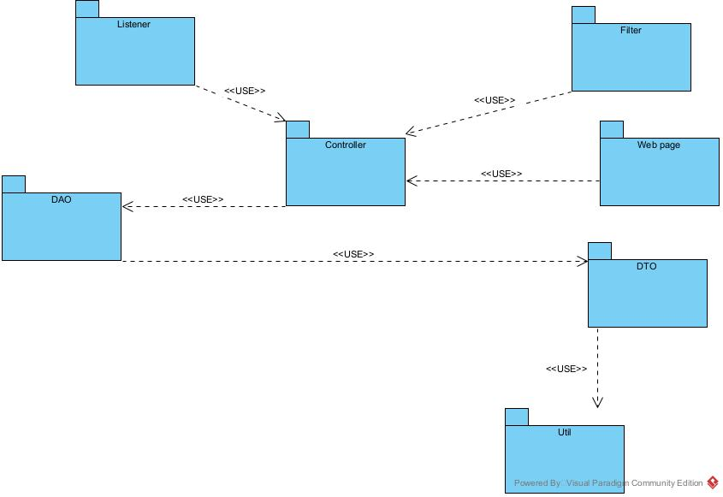

***Package descriptions***

|  |  |  |
| --- | --- | --- |
| **No** | **Package** | **Description** |
| 01 | Controller | This package contains controller classes in the application. Controllers typically handle requests from users (via the UI or other services) and process them, then return the corresponding results. |
| 02 | Web page | This package contains components related to the user interface, including web pages, UI components, CSS files, JavaScript, images, and other resources used to display the interface to users. |
| 03 | DAO | This package contains classes and methods to interact with the database. DAO classes typically perform operations such as querying, adding, modifying, or deleting data from the database. |
| 04 | DTO | This package contains DTO classes, which are objects used to transfer data between different components of the application. DTOs typically contain data fields and accessor methods to get and set data. |
| 05 | Util | This package contains utilities or helper tools used throughout the application. This may include utility methods for string processing, date handling, mathematical functions, or other tools to assist in managing and processing data. |
| 06 | Filter | This package contains filters used to process and filter requests and responses in the web application. Filters are often used to check and authenticate requests, perform preprocessing and postprocessing before and after requests are sent to the application's endpoints. |
| 07 | Listener | There is no description provided for the Listener package in your list. Listeners are commonly used in Java applications to monitor and respond to events occurring within the application, such as application startup events or events from Servlets or other components. |

## 2. Database Design

### a. Database Schema

### b. Table Description

|  |  |  |
| --- | --- | --- |
| **No** | **Table** | **Description** |
| *01* | *<Table name>* | *<Description of the table>* |

# II. Code Designs

### 1. Sequence Diagram(s)

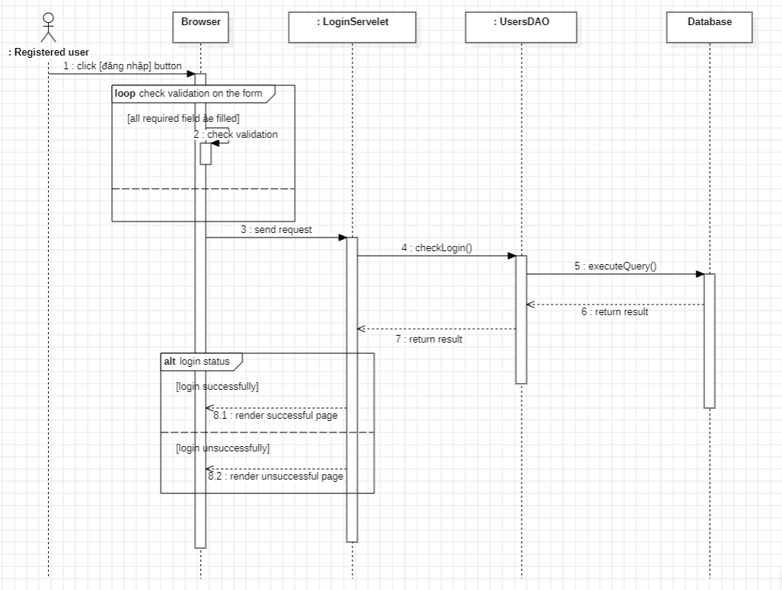

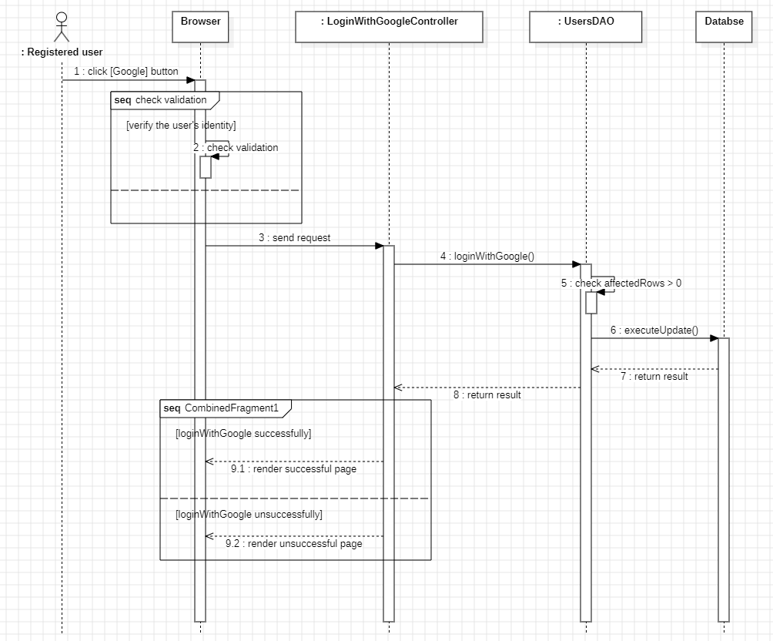

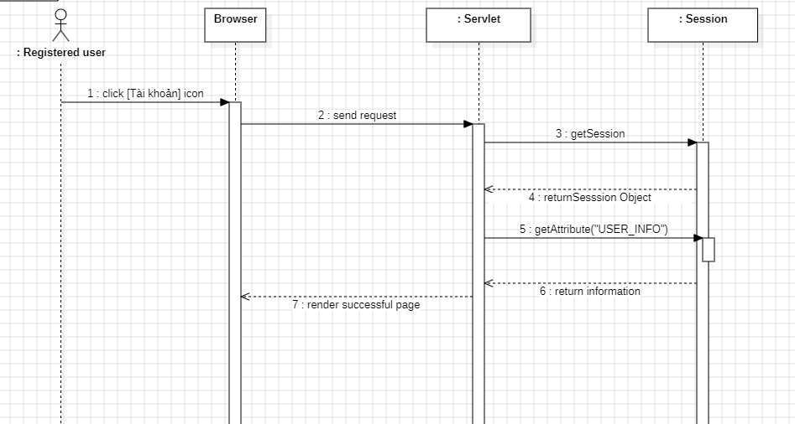

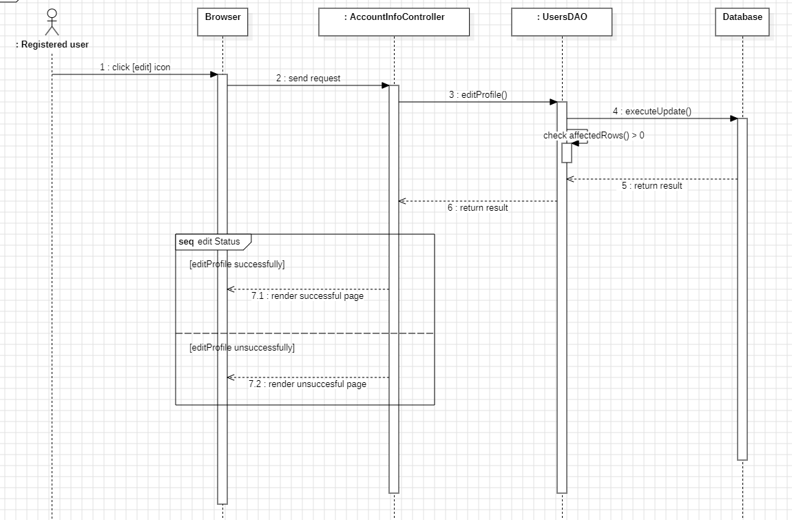

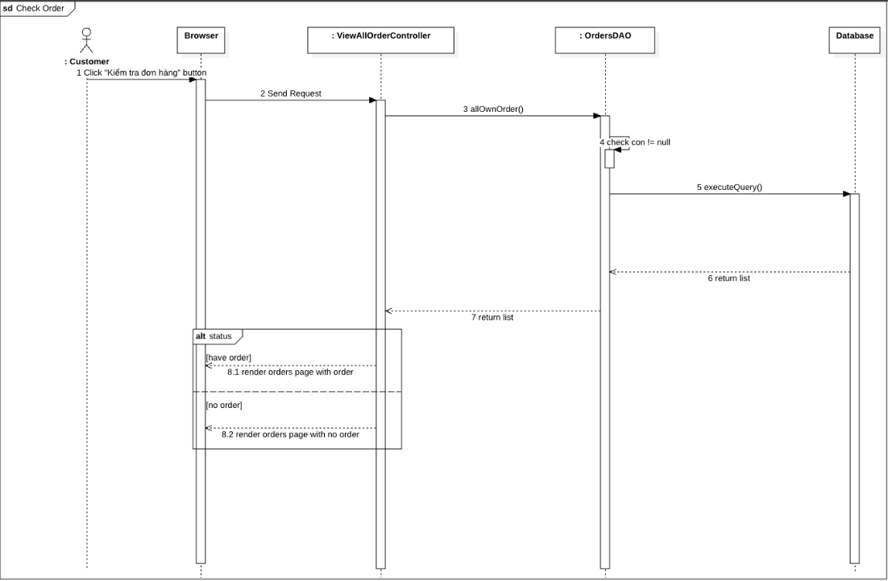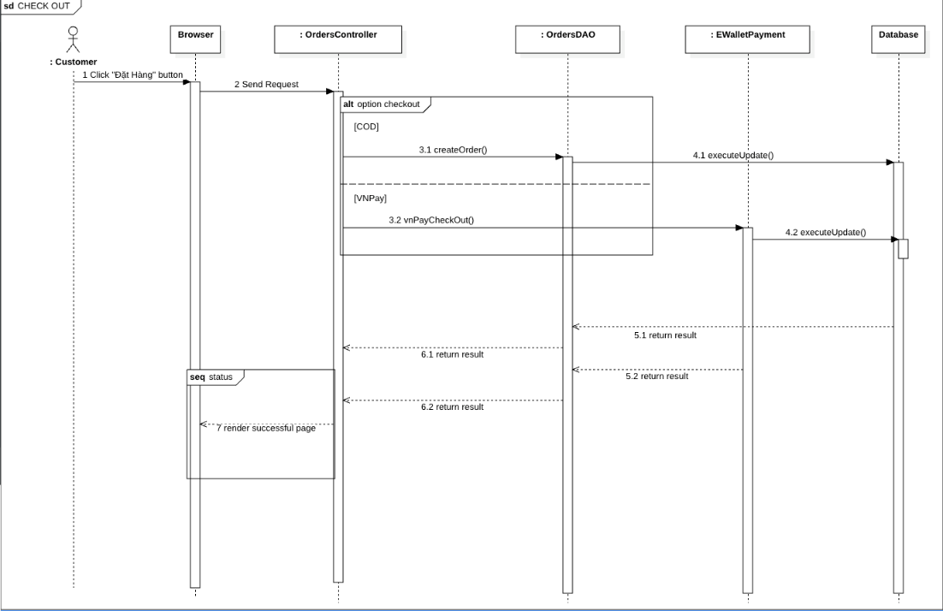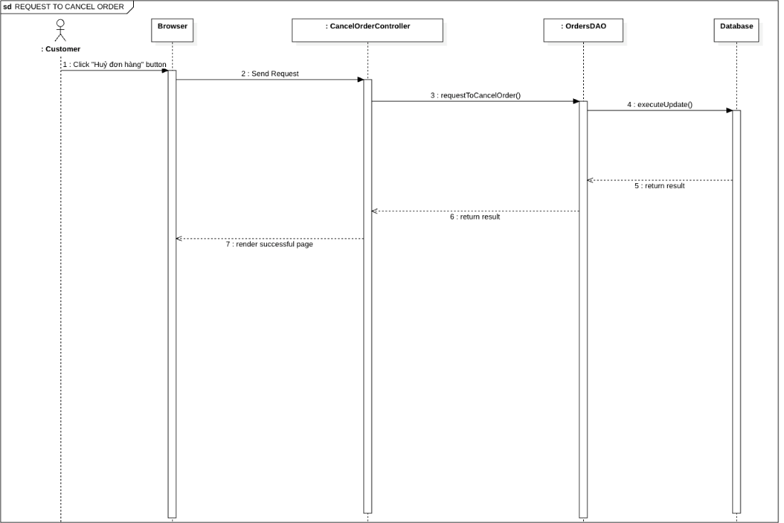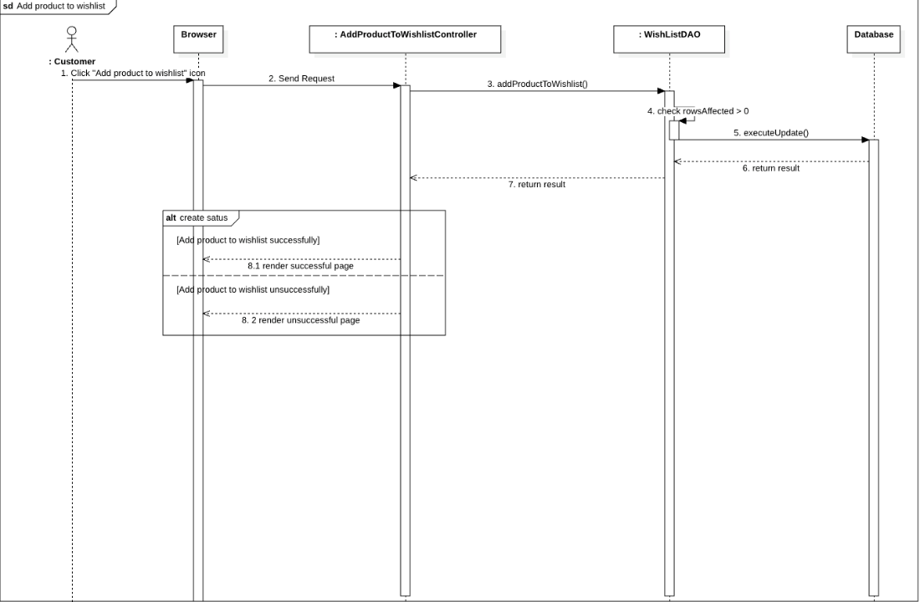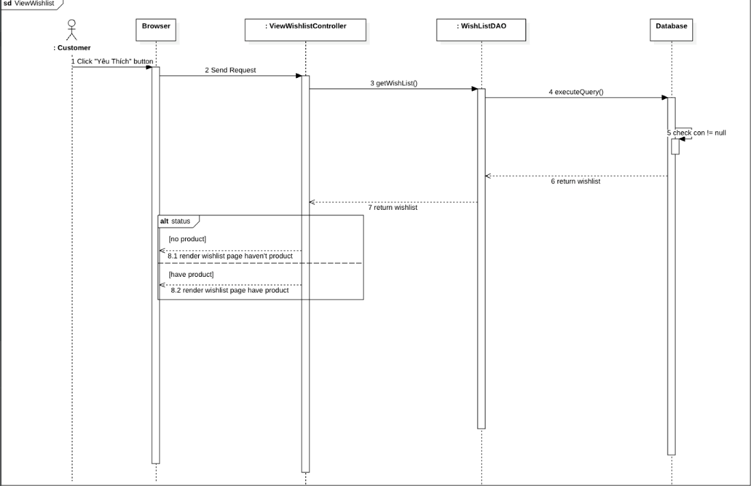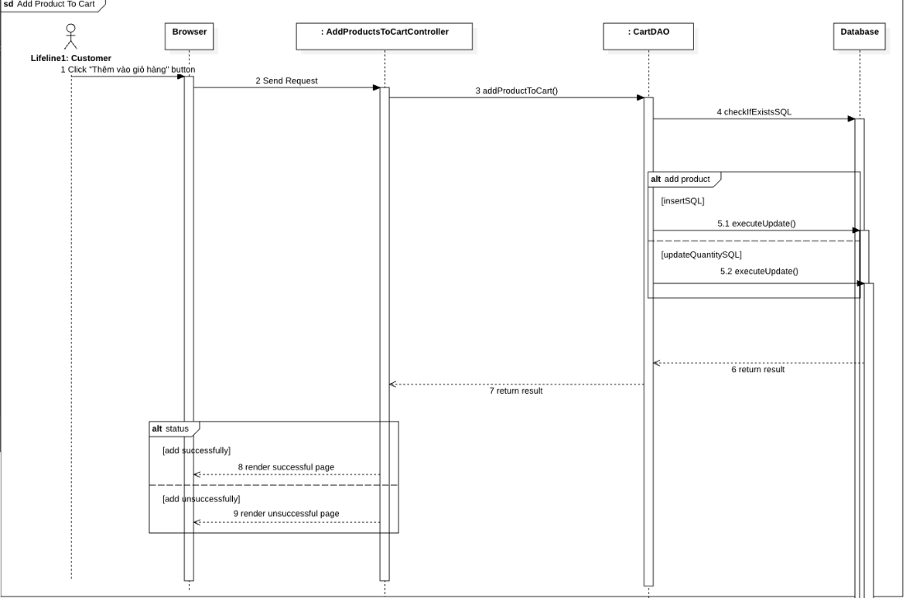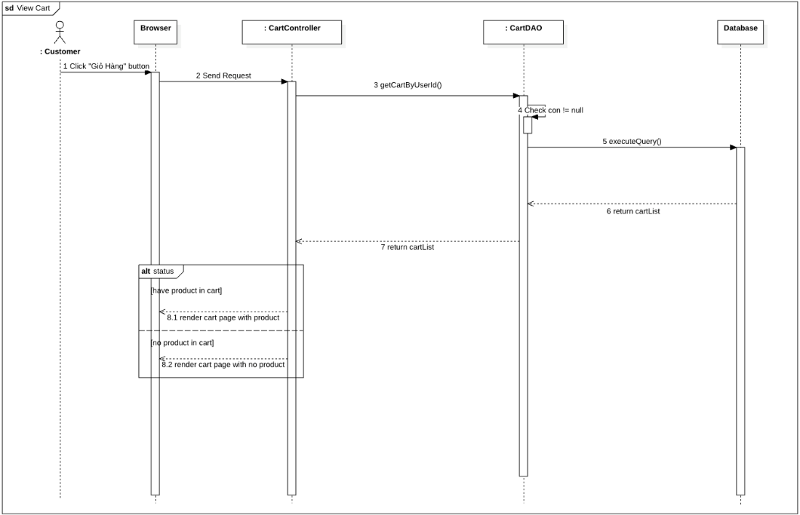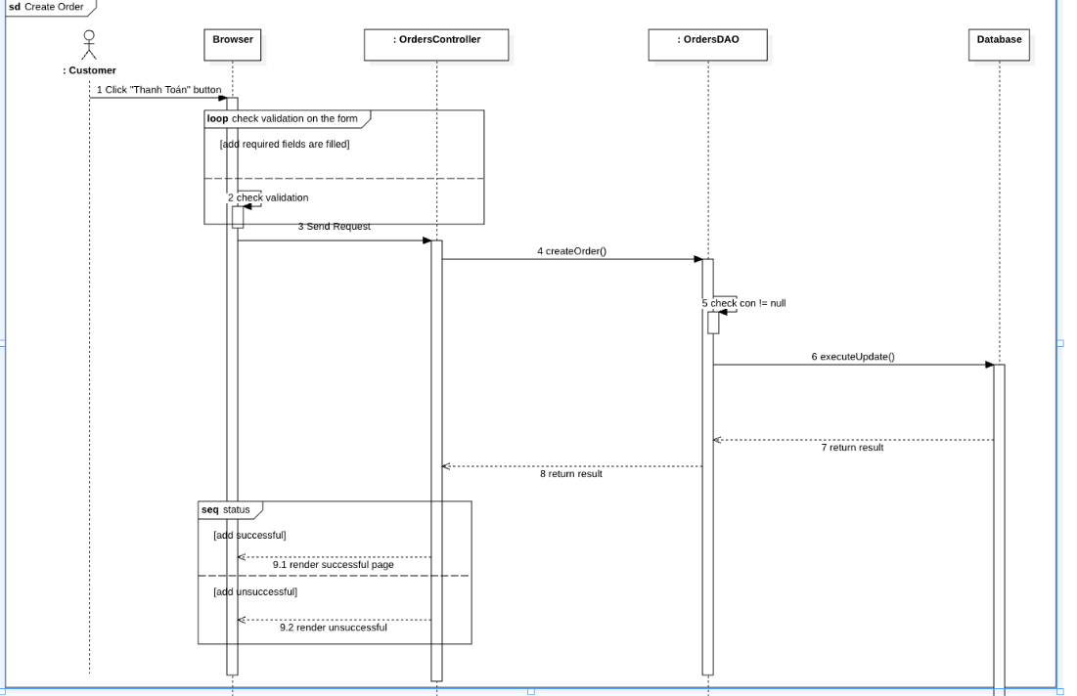

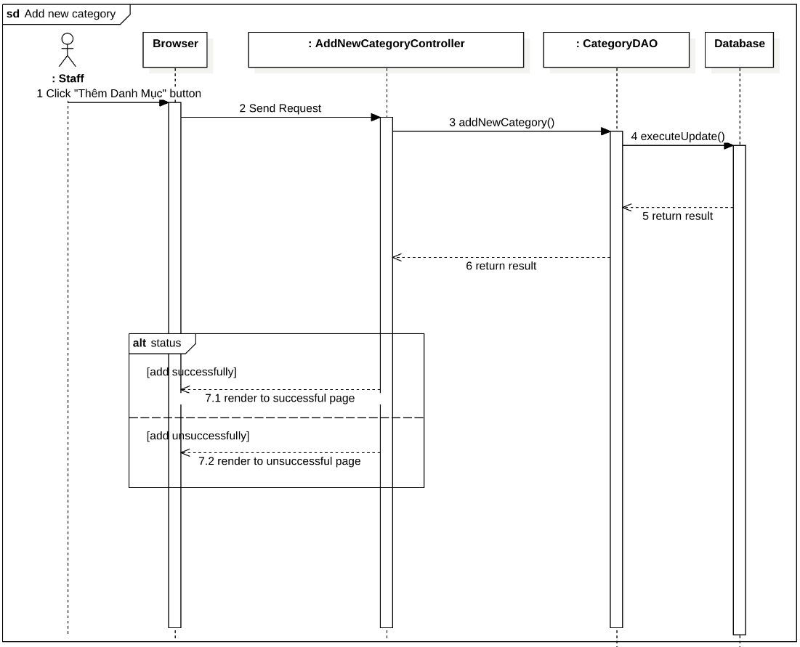

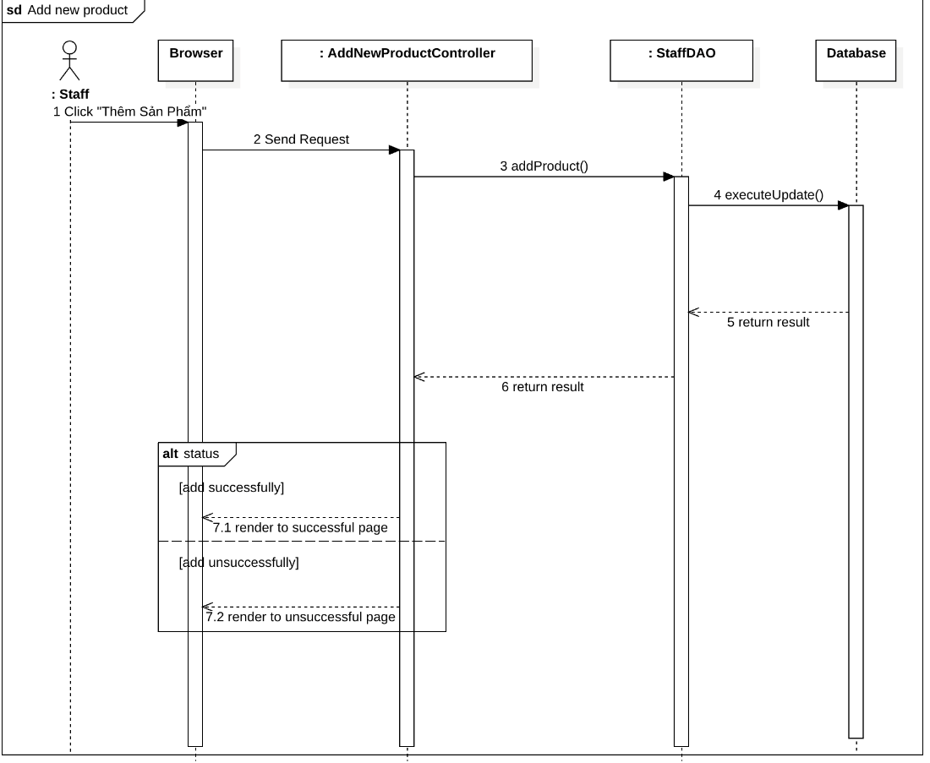

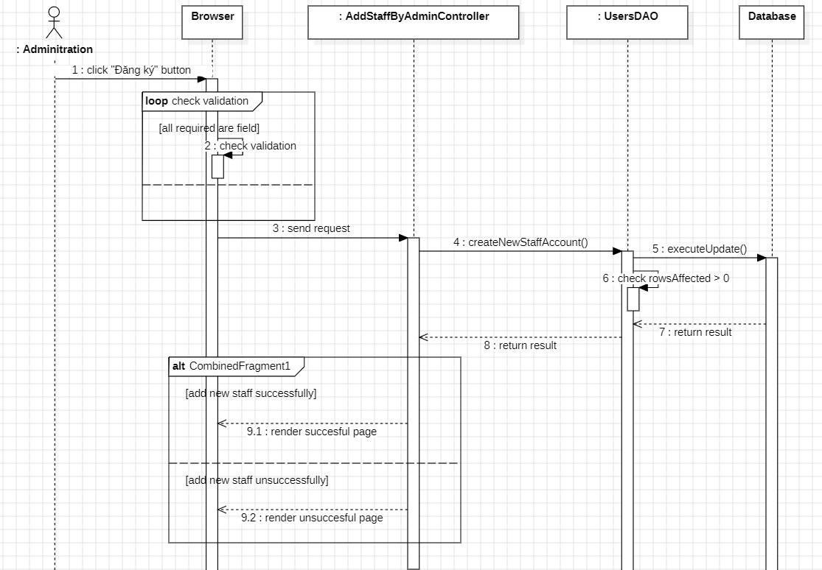

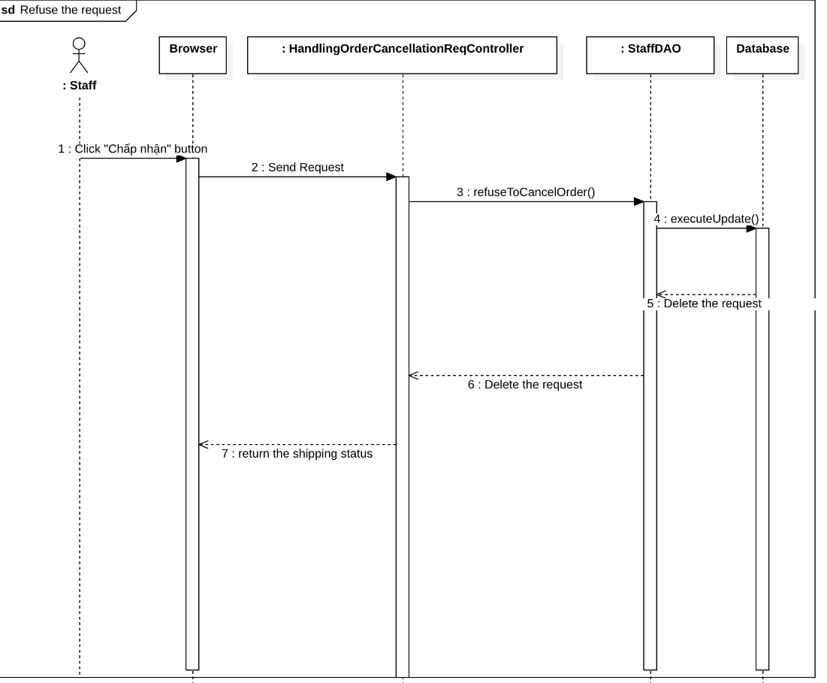

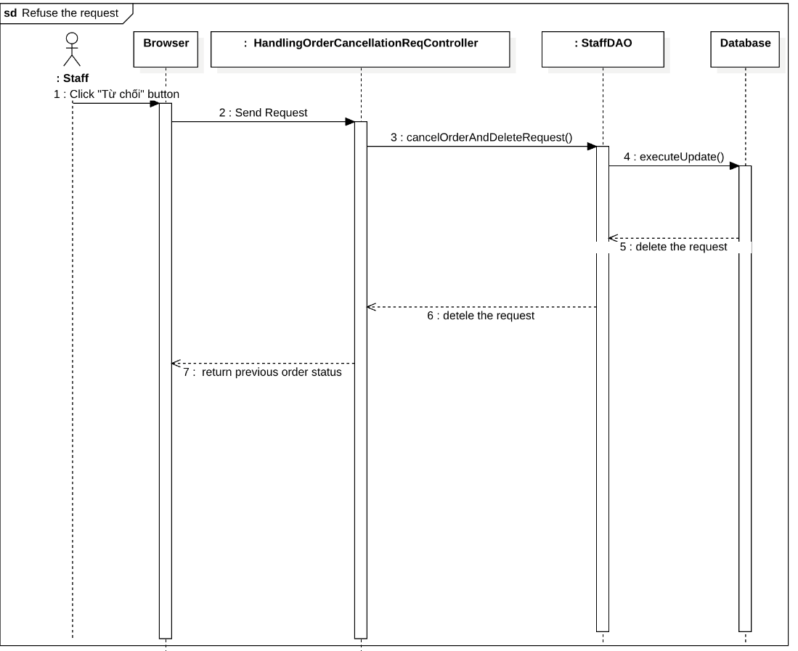

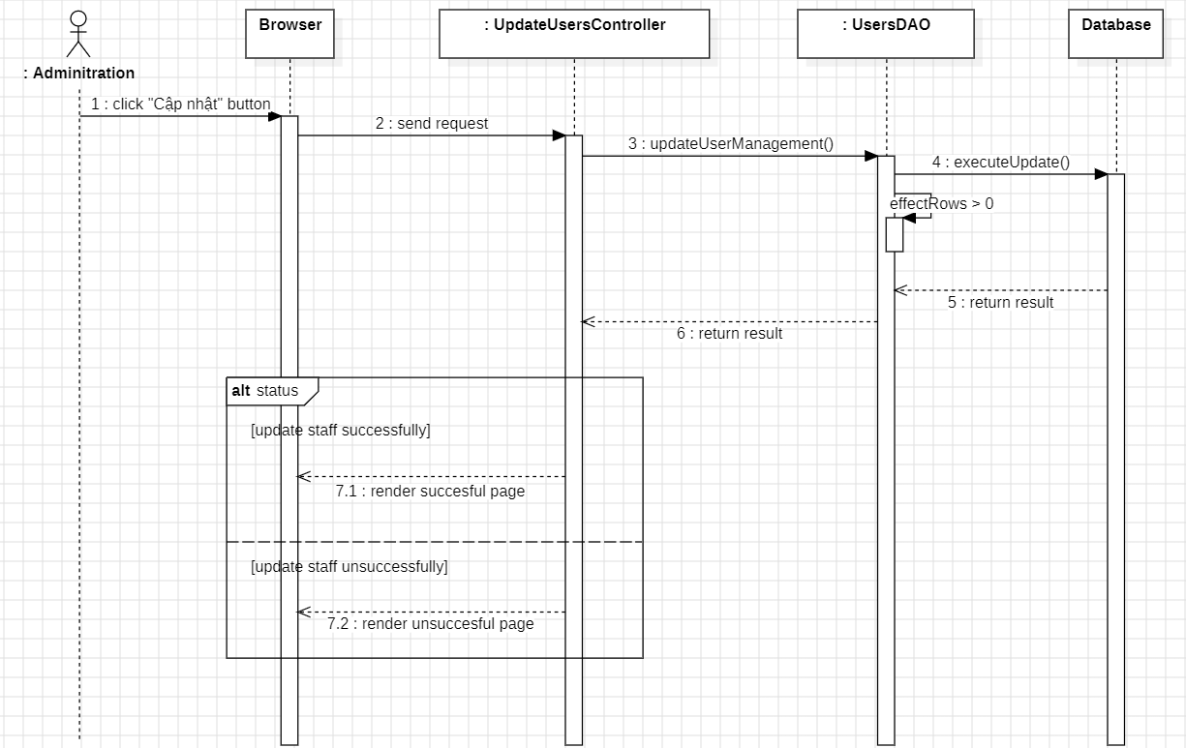

### d. Database Queries

*[Provide the detailed SQL (select, insert, update...) which are used in implementing the function/screen]*

## 2. <Feature/Function Name2>

…